## Problem 2 – My Blog

Create a Web site (HTML5 + CSS3 + images) that looks and behaves like the screenshot below:

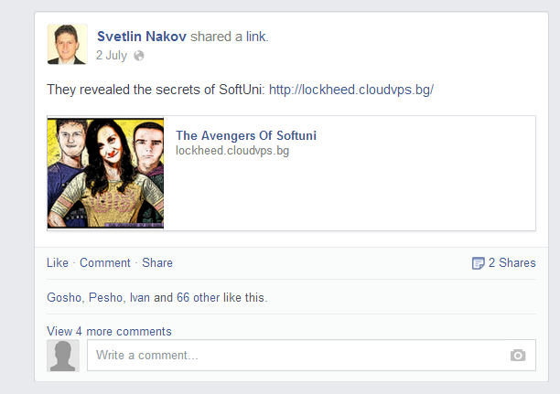

* All the texts in blue are links and when hovered the cursor must be pointer.

### Input

You are given the above screenshot + images and icons on the site, nothing else.

### Output

The output should be valid HTML5 + CSS3 + images that implement the above Web site.

### Constraints

* Font: Helvetica.
* Fixed width: 500px.
* The site should open correctly in Chrome 35.
* Responsive design is not required.
* Pixel-perfect implementation is not required.